### **ML Production Series — Tips to Get Started 4**

As we have already seen the lifecycle of machine learning. It is an iterative process and eventually, you select the best. **Fig-1 shows below** :

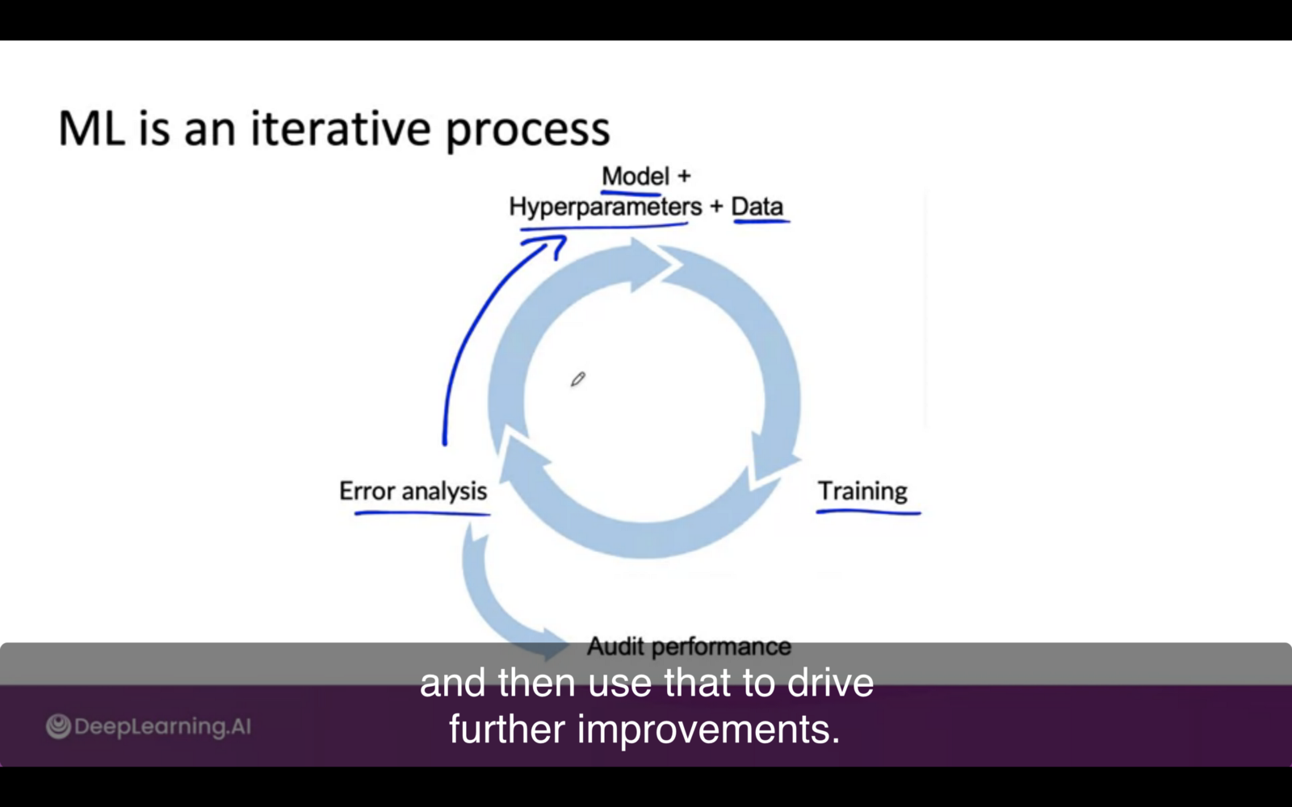Fig-1

### **Model+Data+ Hyperparameter**

Here is a suggestion for the first step **Tips** are shown below **fig-2.**To summarize to get started instead of looking for the best literature try browsing blogs or open-source projects as a reasonable algorithm with good data outperforms the best algorithm with not good data

#### **The first step will decide the efficiency of the next steps in MLSDL (Machine learning software development life cycle)**

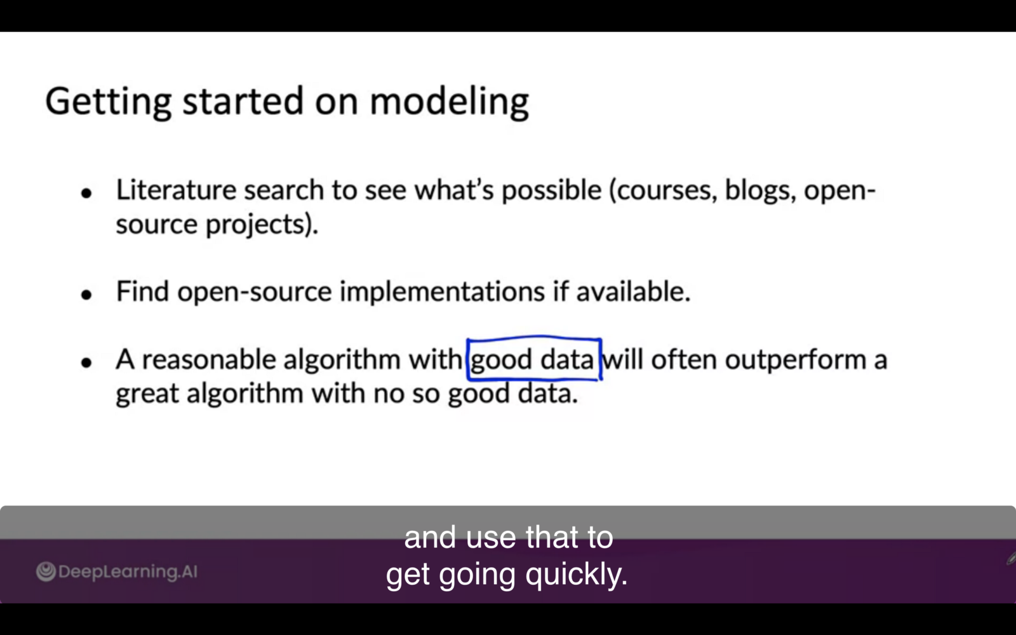Fig-2

#### **Deployment Constraints When Picking Model**

It depends upon the scenario if the goal deploys otherwise if it is not then go for implementation and don't think about it and focus on **baseline** establishment. **Fig-3 below** gives the details

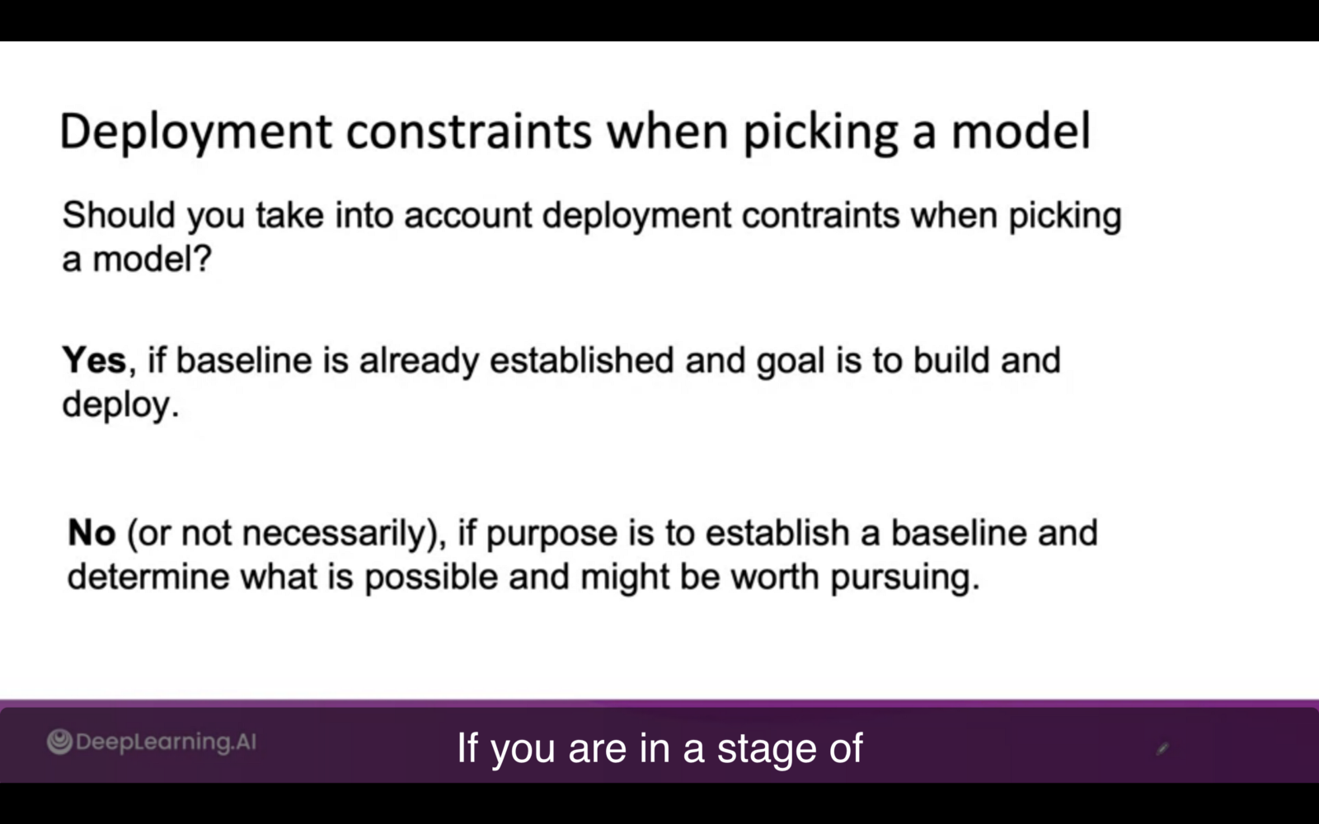Fig-3

#### **Sanity Check for code and Algorithm**

In this sanity check before training the model on the whole dataset, try to use a small check of data. maybe even 1 input. **Fig-4** below shows that maybe we can have different cases of ML application i.e Speech recognition, Image segmentation, and classification. Consider the speech recognition model was trained on. only one audio and it might possible the model predict null values for other examples. Whereas in Image classification you can start with 100,10 even you have 10000 images.

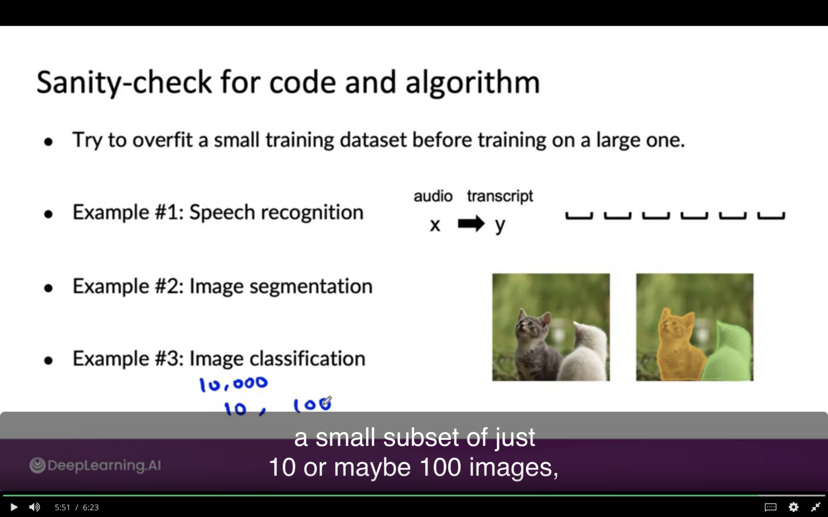Fig-4

How to improve **Performace of model ?** In the next blog we are gonna discover it.